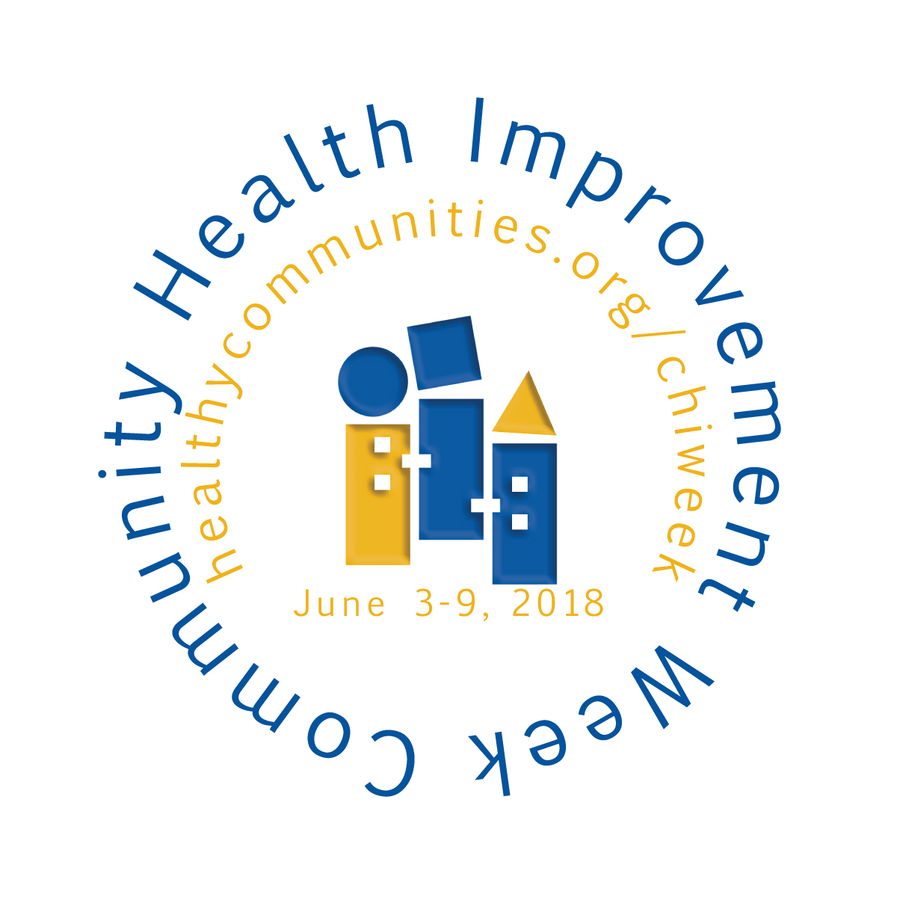
[Press Release Template]
Media Contact:
communityhlth@aha.org
For Immediate Release

[Name of Hospital/Community] Celebrates Community Health Improvement Week June 3-9, 2018!
(DATE) – [Name of hospital] is joining The Association for Community Health Improvement’s annual Community Health Improvement Week on June 3-9, 2018. Community Health Improvement Week is a national event that recognizes community health professionals, organizations and coalitions for their passion and dedication to improving the health of the communities they serve. The week’s primary intent is to highlight the value that community health professionals contribute to improving health in their local towns, cities and counties by raising awareness, demonstrating impact and celebrating community health professionals.
Community health is a multi-sector approach to provide access to preventive health services for all, deliver health education and connects people to resources, and help to ensure the health and safety of the environment in which people live, work and learn. It complements medical care by striving to help people maintain and improve their health every day. Hospitals are increasingly focusing their efforts on reaching their population health goals by identifying and addressing the social determinants of health. By connecting clinical and community issues and partnering with multisector community stakeholders, America’s hospitals are making a huge impact on the health and well-being of their communities.

During this special week, hospitals, health care systems, public health organizations, community-based organizations and health improvement coalitions across the country will engage their communities to raise awareness and understanding of community health and demonstrate its benefits by holding forums, educational events and distributing communications about the community health programs they and their organizations run. ACHI will release new resources during this special week to support the field on their community health improvement journeys. For more information and a schedule of events, visit www.healthycommunities.org/chiweek.
______________________________________
About the Association for Community Health Improvement
ACHI, an affiliate of the American Hospital Association, is a national organization working to expand knowledge and enhance performance for community health, community benefit and community health professionals. The association provides education, peer networking, resources and practical tools to more than 1,000 members from the health care, public health and community development sectors and related organizations.

